**TASK 1**

* Created my_folder directory and created a file with name my_file with some text.

* Created a file with name another_file.txt with some text.



* Concatenate the content of ""another_file.txt"" to ""my_file.txt"" and display the updated content. Finally, list all files and directories in the current directory.

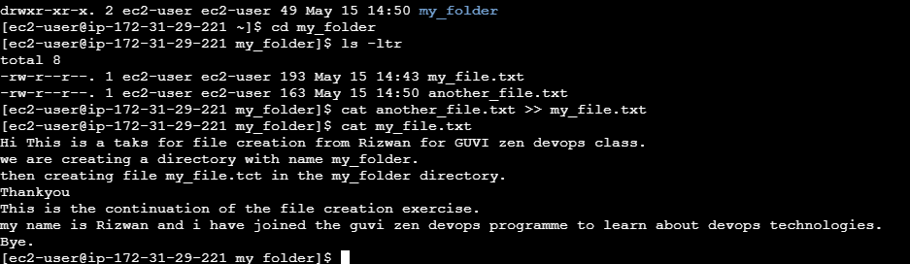

**Task 2**

* Create 20 files with .txt extensions

* rename the first 5 files to .yml



